Nursery
Autumn | Spring | Summer
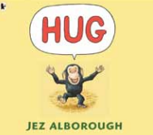  Hug  by Jez Alborough | 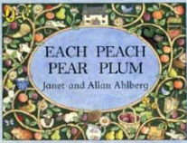  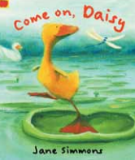  Each Peach, Pear Plum  by Janet and Allan Ahlberg | 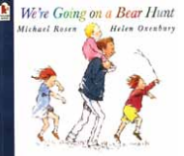  We’re Going on a Bear Hunt  by Michael Rosen
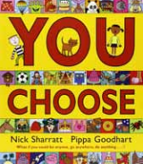  You Choose  by Nick Sharratt | 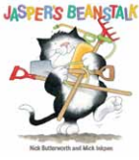  Jasper’s Beanstalk  by Nick Butterworth | 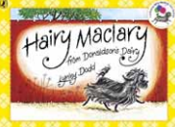  Hairy Maclary  by Lynley Dodd
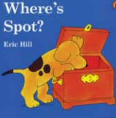  Where Spot?  By Eric Hill | Come on, Daisy  by Jane Simmons | 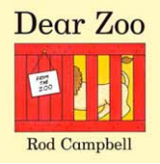  Dear Zoo  by Rod Campbell
Brown Bear, Brown Bear, What Do You See?  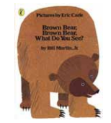  By Bill Martin, Jr | 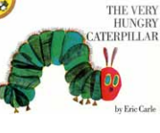  The Very Hungry Caterpillar  by Eric Carle | 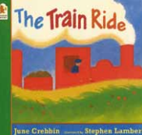  The Train Ride  by June Crebbin

Reception
Autumn | Spring | Summer
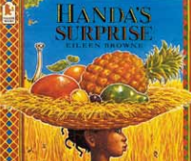  Handa Surprise  by Eileen Browne | 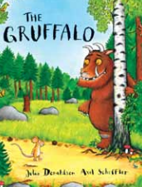  The Gruffalo  by Julia Donaldson | 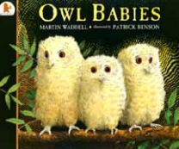  Owl Babies  by Martin Waddell
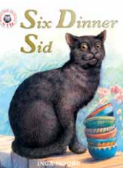  Six Dinner Sid  by Inga Moore | 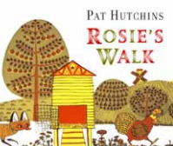  Rosie’s Walk  by Pat Hutchins | 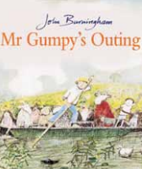  Mr Grumpy’s Outing  by John Burningham
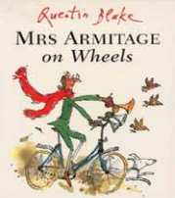  Mrs Armitage on Wheels  by Quentin Blake | 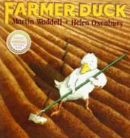  Farmer Duck  by Martin Waddell | 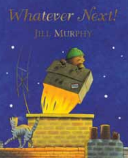  Whatever Next!  by Jill Murphy
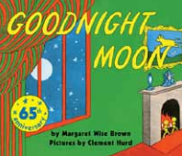  Goodnight Moon  by Margaret Wise Brown | 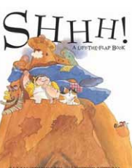  Shhh! By  by Sally Grindley | 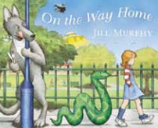  On the Way Home  by Jill Murphy
Year 1
Autumn | Spring | Summer
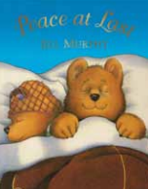  Peace at Last  by Jill Murphy | The Elephant and the Bad Baby  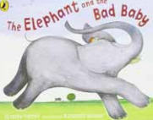  by Elfrida Vipont | 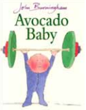  Avocado Baby  by John Burningham
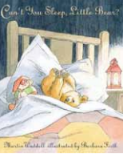  Can’t You Sleep Little Bear?  by Martin Waddell | 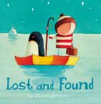  Lost and Found  by Oliver Jeffers | Where the Wild Things Are  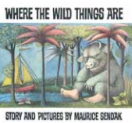  by Maurice Sendak
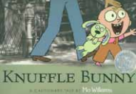  Knuffle Bunny  by Mo Willems | 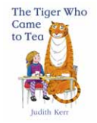  The Tiger Who Came to Tea  by Judith Kerr | 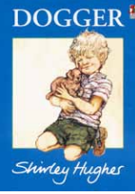  Dogger  by Shirley Hughes
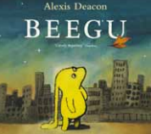  Beegu  by Alexis Deacon | 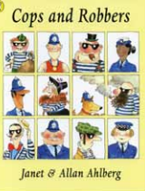  Cops and Robbers  by Janet & Allan Ahlberg | 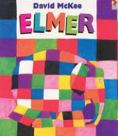  Elmer by David Mckee

Year 2
Autumn | Spring | Summer
Who’s Afraid of The Big Bad Book?  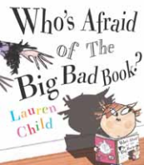  by Lauren Child | Gorilla  by Anthony Browne  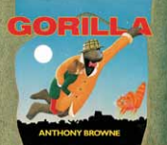 | 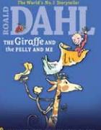  The Giraffe and the Pelly and Me  by Roald Dahl
Dr Xargle’s Book of Earthlets  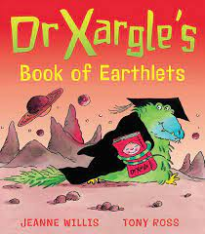  by Jeanne Willis | The Flower  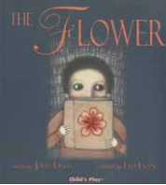  by John Light | 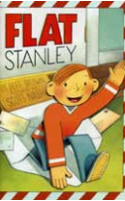  Flat Stanley  by Jeff Brown
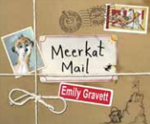  Meekat mail  by Emily Gravett | 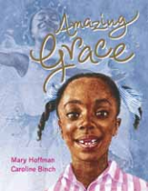  Amazing Grace  by Mary Hoffman | The Owl who was Afraid of the Dark  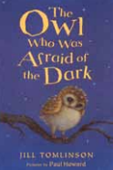  by Jill Tomlinson
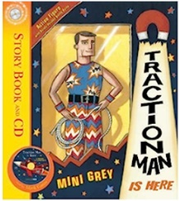  Traction Man is Here  by Mini Grey | Not Now, Bernard  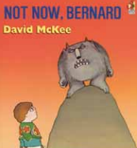  by David Mckee | Frog and Toad Together  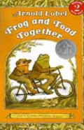  by Arnold Lobe
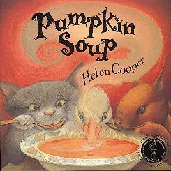  Pumpkin Soup  by Helen Cooper | Tuesday  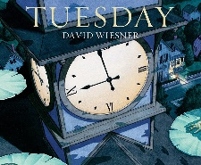  by David Wiesner | 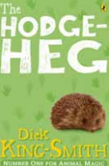  The Hodge-Heg  by Dick King- Smith
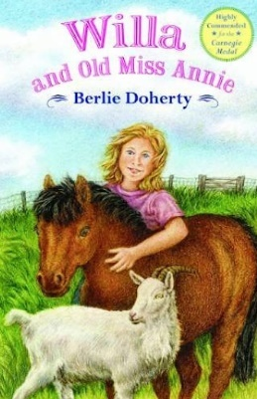  Willa and Old Miss Annie  by Berlie Doherty | Fantastic Mr Fox  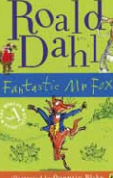  by Roald Dahl | Emily Brown and the Thing  by Cressida Cowell  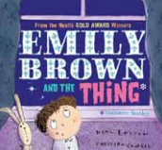

Year 3
Autumn 1 | Autumn 2 | Spring 1 | Spring 2 | Summer 1 | Summer 2
The Iron Man  by Ted Hughes  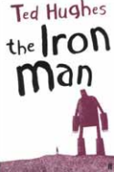 | The Sheep-Pig  by Dick King-Smith  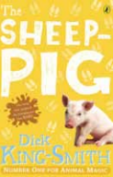 | The Lion, The Witch and The Wardrobe  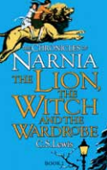  by C.S.Lewis | Hansel and Gretel by Anthony Browne  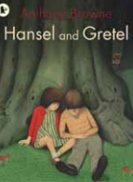 | The Battle of Bubble and Squeak  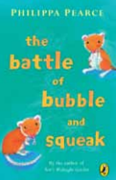  by Philippa Pearce | Cat Tales  by Linda Newbery  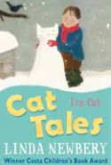
Year 4
Autumn 1 | Autumn 2 | Spring 1 | Spring 2 | Summer 1 | Summer 2
Perry Angel Suitcase  by Glenda Millard  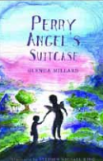 | Voices in the Park by Anthony Browne  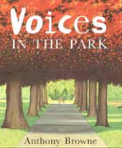 | Charlotte’s Web  by E.B.White  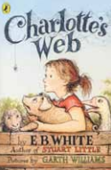 | The Firework Maker’s Daughter  by Philip Pullman  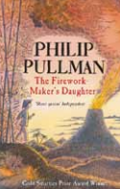 | Why the Whales Came  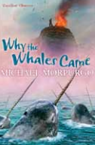  by Michael Morpurgo | Bill’s New Frock  by Anne Fine  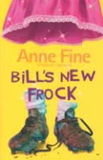

Year 5
Autumn 1 | Autumn 2 | Spring 1 | Spring 2 | Summer 1 | Summer 2
Tom’s Midnight  by Philippa Pearce Garden  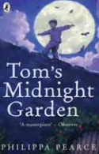 | The Midnight Fox by Betsy Byars  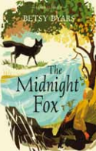 | Street Child by Berlie Doherty  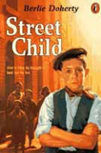 | Varjak Paw  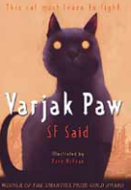  by S. F. Said | Wolf Brother  by Michelle Paver  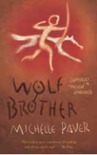 | The Wolves of Willoughby Chase by Joan Aiken  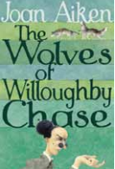

Year 6
Autumn 1 | Autumn 2 | Spring 1 | Spring 2 | Summer 1 | Summer 2
Holes  by Louis Sachar  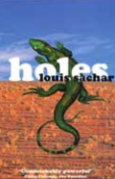 | Fireweed  by Jill Paton Walsh  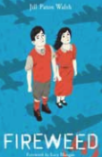 | Clockwork  by Philip Pullman  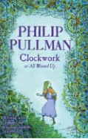 | 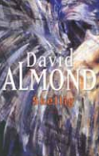  Skellig by David Almond | The Hobbit by  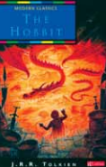  J.R.R Tolkien | River Boy  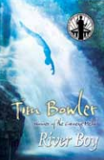  by Tim Bowler

